**Task 1:**

**1. Blood glucose levels for obese patients have a mean of 100 with a standard deviation of 15. A**

**researcher thinks that a diet high in raw cornstarch will have a positive effect on blood glucose**

**levels. A sample of 36 patients who have tried the raw cornstarch diet have a mean glucose**

**level of 108. Test the hypothesis that the raw cornstarch had an effect or not.**

**Solution:**

Given data: Mean= 100, Standard deviation = 15, sample = 36, and level = 108.

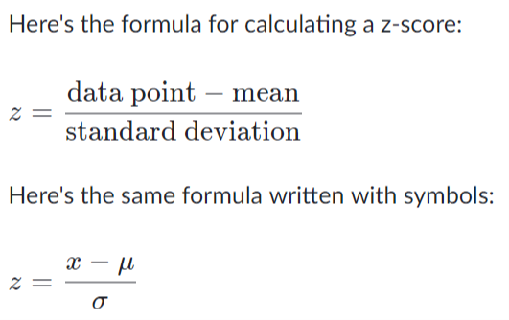

Here, σmean = σ / √N = 15 / √36 =2.5

$⇒$ z = 108-100/2.5 = 3.2